Online Restaurants Ordering System

Mbrothers Solution

14/12, Shekhertek, Mohammodpur, Dhaka, Bangladesh

Abstract
ONLINE FOOD ORDERING SYSTEM is an application designed primarily for use in the food delivery industry. This system will allow hotels and restaurants to increase scope of business by reducing the labor cost involved. The system also allows to quickly and easily managing an online menu which customers can browse and use to place orders with just few clicks. Restaurant employees then use these orders through an easy to navigate graphical interface for efficient processing.

Introduction
It is known globally that, in today’s market, it is extremely difficult to start a new small-scale business and live-through the competition from the well-established and settled owners. In fast paced time of today, when everyone is squeezed for time, the majority of people are finicky when it comes to placing a food order. The customers of today are not only attracted because placing an order online is very convenient but also because they have visibility into the items offered, price and extremely simplified navigation for the order.

Online ordering system that I am proposing here, greatly simplifies the ordering process for both the customer and the restaurant. System presents an interactive and up-to-date menu with all available options in an easy to use manner. Customer can choose one or more items to place an order which will land in the Cart. Customer can view all the order details in the cart before checking out. At the end, customer gets order confirmation details. Once the order is placed it is entered in the database and retrieved in pretty much real time. This allows Restaurant Employees to quickly go through the orders as they are received and process all orders efficiently and effectively with minimal delays and confusion.

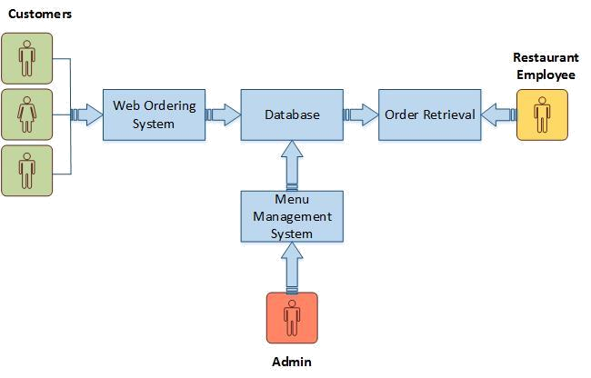
System Model:

Figure 1

The structure of the system can be divided into 3 main logical components:

- Web Ordering System- provides the functionality for customers to place their order and supply necessary details.
- Menu Management-allows the restaurant to control what can be ordered by the customers

- Order Retrieval System-This is a final logical component. Allows restaurant to keep track of all orders placed. This component takes care of order retrieving and displaying order information.

Product Function:

The Online Food Ordering System application would have the following basic functions:

Web Ordering System Module

This module provides the functionality for customers to place their order and supply necessary details. Users of the system, namely restaurant customers, must be provided the following functionality:

- Navigate the restaurant’s menu.
- Select items from the menu.
- Select size, flavors, choices etc…
- Add an item to their current order.
- Review their current order.
- Remove an item/remove all items from their current order.
- Apply coupon for discount
- Provide payment details. (PayPal and Square) or Redeem loyalty points
- Create an account or guest checkout
- Log in to the system.
- Place an order.
- Deliver or Pick-up options.
- Collect loyalty points.
- Select payment method and make payment
- Receive confirmation in the form of an order number after confirmation by restaurant employee.
- View and print order placed.
- Manage customer account.
- Track order by order number.
- Get notification after ready the order.
- Reorder an order where customer can add and remove items
- Customer will get notifications of offers and promotions on a regular basis.
- Predictive search options of food item.
- Provide comments and review against and order.
- Customize order
- Group order , (send notification by email to guests and they will add meal to the order)
- Preorder

Out of all the functions outlined above, Account Creation and Management only will be used every time a customer places an order. This will allow simplifying the overall user experience.

Menu Management System Module

This module provides functionality for the power user-Administrator only. It will not be available to any other users of the system like Restaurant Employees or Customers.
Manage Menu:
- Add/update/delete food category to/from the menu.
- Add/update/delete food sub-category to/from the menu.
- Add /update/delete food item to/from the menu.
- Add /update/delete size
- Add /update/delete ingredients
- Add /update/delete choice and additional information
- Add /update/delete Extra item
- Update price for a given food item.
- Update additional information (description, photo, etc.) for a given food item.

Manage Users:
- Admin can create different types of role/group for different employees/users
- Admin can give permission to each page’s each function level to the roles.
- A user/employee can be assigned in one or many group.

Manage Website:
- Edit each text of the website
- Change contact and email information
- Add/edit/delete slider images
- Change logo, site name
- Photo Gallery wise image upload
- Social media integrations, Facebook, yelp, Instagram , Tweeter
- Meta description and meta tag management

Manage Settings:
- General Settings, Business days , holidays , business houres
- Store Settings, location
- Payment method settings
- Tax settings ,
- Order setting, minimum order preparing time, notification for preorder,
- Cupons
- Loyality points
- Generate and manage coupon
- Manage loyalty points
- Manage Ad and Promotions
- Push alert Settings
- Email settings and template

Report Module:
- Customer status report
- Order details report
- Daily, Monthly , Date range wise order summary
- Customer wise order report
- Item Wise sell report
- Payment method wise sell report

Order Retrieval System Module

This is the simplest module out of all 3 modules. It is designed to be used only by restaurant employees, and provides the following functions:
- Receive new order notifications
- Order confirmation based on time and ingredient availability
- Upon order confirmation customer will receive confirmation.
- Cancel order with specific reason
- Get the details view of order
- Change status after ready the foods.
- Change status after delivery.
- Receive cash for cash on delivery.
- Place manual order from admin panel
- Edit order (If you want)
- Custom orders manage (Need to discuss)

Frontend Design:
- Frontend design will look like https://chipotle.com and the menu appearance and menu selection and checkout process will be similar to chipotle.
- Social media functionalities will be added with the frontend.
- Ourburritobrothers team will provide all the necessary images, API keys, permissions and resources.

Mobile Apps:
- Will Provide mobile apps for both android and ios platform with the similar looks and feels of the ordering website.
- Frequently ad / offer/ promotion notifications

Tools and Techniques:
- Frontend Language: Html, CSS, Javascript, Ajax, Json, Bootstrap
- Server Language : Php, Node.js
- Database: Mysql
- Framework : Customize framework.

Schedule:
 | Module | Development Time
1. | Admin Module (Settings, User, Menu, Order) | 25 days
2. | Food Order Website | 15 days
3. | Mobile Apps (android and IOS) | (5 days interval) +15 days
 | Total | 55 days

